Name : AkshaITHA POOJARY

Usn : 4al17is004

1.Write a C program to count distinct element in an array

#include<stdio.h>

#include <stdlib.h>

static int remove_duplicates(int* nums, int arr_size)

{

if (arr_size &lt;= 1) {

return arr_size;

}

int i = 0, j, count = 1;

while (i &lt; arr_size) {

for (j = i + 1; j &lt; arr_size &amp;&amp; nums[i] == nums[j]; j++) {}

if (j &lt; arr_size) {

nums[count++] = nums[j];

}

i = j;

}

return count;

}

int main(void)

{

int nums[] = {1,1,2,3,4,4,5,6,6,6};

int size = sizeof(nums)/sizeof(nums[0]);

printf(&quot;Original array:\n&quot;);

int i;

for (i = 0; i &lt; size; i++) {

printf(&quot;%d &quot;, nums[i]);

}

int count = remove_duplicates(nums, size);

printf(&quot;\nAfter removing duplicates from the above sorted array:\n&quot;);

for (i = 0; i &lt; count; i++) {

printf(&quot;%d &quot;, nums[i]);

}

printf(&quot;\n&quot;);

return

}

FLOWCHART FOR DISTINCT NUMBERS IN ARRAY

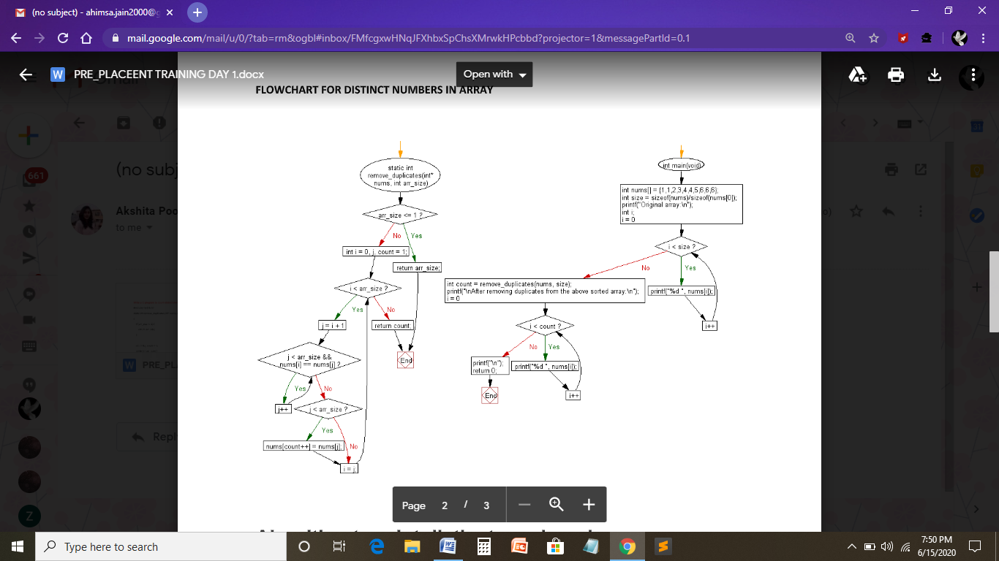

Algorithm to print distinct numbers in an array

1. Declare and input the array elements.
2. Traverse the array from the beginning.
3. Check if the current element is found in the array again.
4. If it is found, then do not print that element.
5. Else, print that element and continue.